# Workshop 6 - Week 8 - CSY2085 – Server Administration and Security

## Workshop: Linux Server VM on Google Cloud

## Getting Google Cloud Credit

1. Here is the URL you will need to access in order to request a Google Cloud Platform coupon. You will be asked to provide your university email address and name. An email will be sent to you to confirm these details before a coupon is sent to you.

[**Student Coupon Retrieval Link**](https://url.uk.m.mimecastprotect.com/s/y6EyCAQP4Un7D00t85y2n?domain=gcp.secure.force.com)

1. You will be asked for a name and email address, which needs to match the domain. You will then be sent an email to verify your email address. A confirmation email will be sent to you with a coupon code with a link to redeem your code.
2. You need to have google email address to associate with this coupon. You can use an existing **GMAIL account** if you have one or you will need to create one.

***Note:*** You can request a coupon from the URL and redeem it until **16/6/2024.** The coupon will be valid through **16/2/2025.** You can only request ONE code per unique email address.

## Task 1 - Creating a Ubuntu VM Instance on Google Cloud

1. Click on the following link to login in into the google cloud using a **GMAIL ID**.

<http://console.cloud.google.com/education>

You will be presented with a page similar to the following:

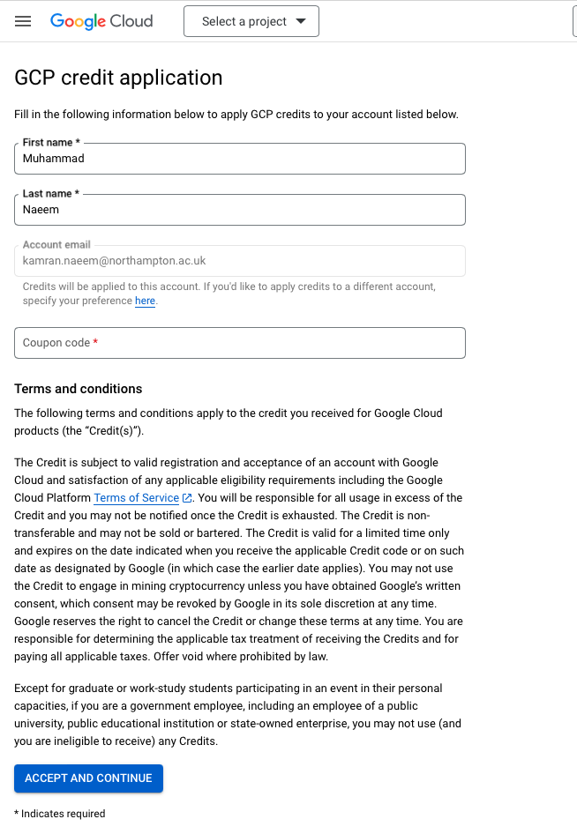

1. “**Select a project**”. **Create a new project**. Give your project a name using your student ID, example **CSY2085-1234567** and Location **No organization** and then **Create.**
2. Open the menu on the top left-hand side of the console.

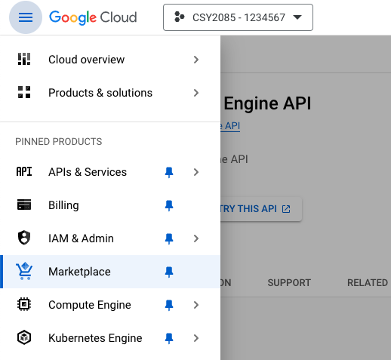

Scroll down the Menu, until you see the ‘**Compute Engine’** option

Click on the ‘**Compute Engine**’ option – from the menu that appears, select the ‘**VM Instances**’ option (a VM Instances tile should be displayed, see figure below)

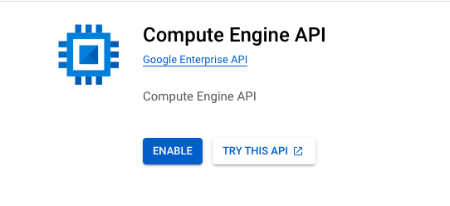

### Create a virtual machine instance

1. Click Enable, then Create instance button.
2. In the name box set your instance name to you initials followed by your student number eg: **1234567 (Whatever you type, must be in lower case)**
3. Set the region and zone to “**us-east4-c**”
4. Under ‘**Machine type**’, leave it the default
5. In the ‘**Boot disk**’ section, click on ‘**Change**’ and select “**Ubuntu 20.04 LTS**”, then click ‘**Select**’
6. In the ‘Firewall’ section, select **both** ‘**Allow HTTP traffic’** and ‘**Allow HTTPS traffic’** checkboxes.
7. Click the ‘**Create**’ button to create the instance. ‘Ignore the line about being billed for this instance’?
8. While the instance is being created, take your time to explore the VM instances page. At the bottom, you can see the list of your VMs (If you have previously created any). At the top, you can see a control panel allowing you to create a new VM instance or an instance group, Start, Stop, Reset and Delete instances

**Connect to your instance**

1. Once the VM instance has been created, it will be listed (as below)
2. Make sure you select the instance that you created and click on the ‘**SSH**’ button, and select the ‘**Open in Browser window**’ option

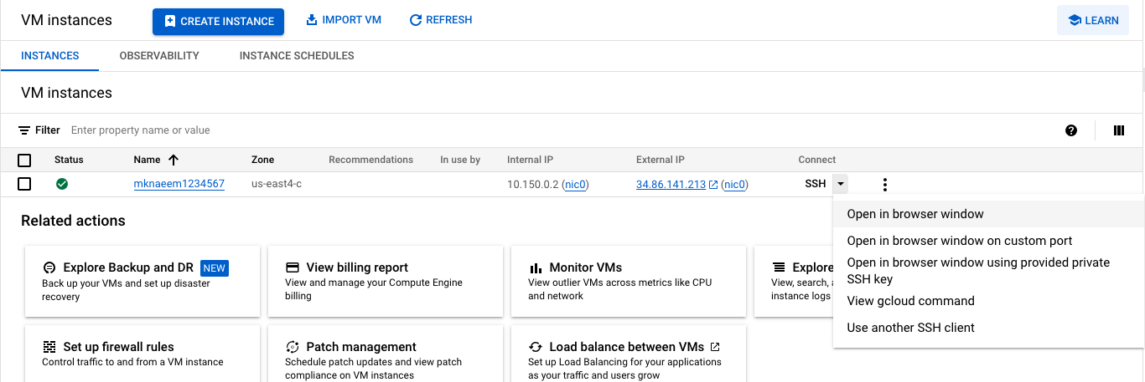

A virtual Ubuntu Server will then open in a new browser window, similar to below

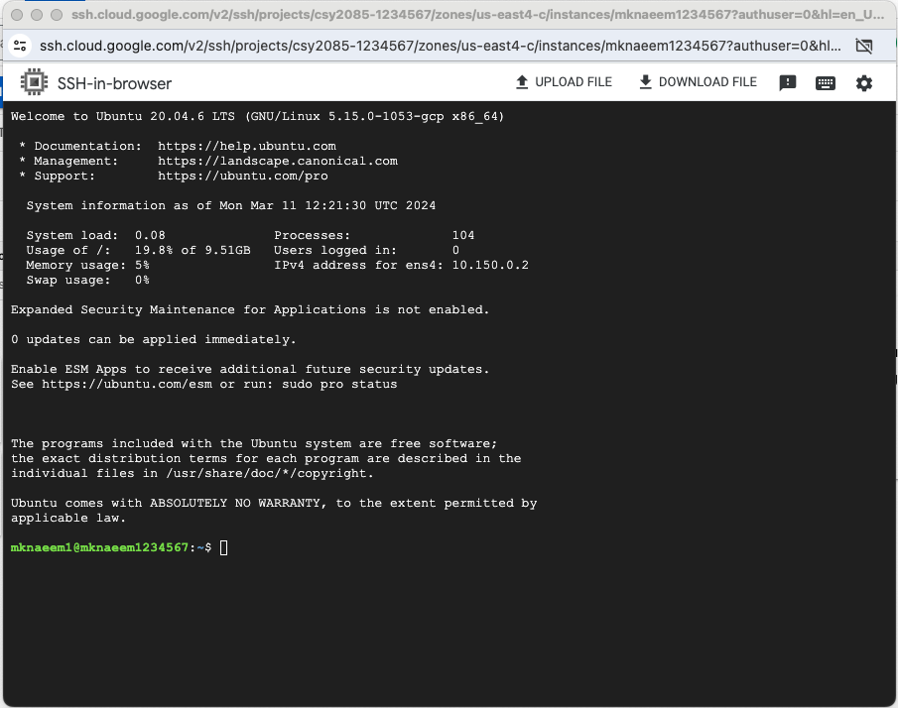

1. Capture your Server screen and paste it here

**[paste your screenshot here]**

1. Go Back to the Google Cloud Console and take a note of your server’s IP Addresses shown there.

**Internal IP address:**

**External IP address:**

**Question: What’s the significance of these two addresses?**

How do you display the IP address in the Linux shell?

Hint: you might need to install the net-tools package first

**sudo apt install net-tools**

1. Set the **root** password by entering the following command

**sudo passwd root**

1. Choose a password for you server and confirm it – **take a note of your password**
2. Login as root by entering the following command (**use the password created in Step 6)**

**su root**

1. Capture your screen and paste it here

**[paste your screenshot here]**

## Task 2 - Linux Bash Shell Commands

1. Make sure that you are logged in as **root**
2. Create a user:
   1. Enter the following command into the Linux shell, substituting “yourusername” with your own name:  
        
      **adduser username**

It prompts for password and other info, complete these login as the created user and verify the group it’s allocated  
  
How do you display the new user you just created and the group they belong in?

Capture the screen, showing the new user and their group   
  
**[paste your screenshot here]**

* 1. Create a new group and move your user to the new group   
       
        
     Capture the screen, showing the new user’s details, and paste the screen below:  
       
     **[paste your screenshot here]**
  2. Now log out of the current shell with the command:  
       
     **exit**

1. Log in with the new username that you have just created by entering the following command

**su yourusername**

* 1. Try and look into a restricted directory:  
       
     **ls -al /root**  
       
     **Question: Could you do this, and why?**   
       
     **[your answer here]**
  2. To perform “superuser” or "root" functions, you need to use the “sudo” command prefix. Try it now by entering:  
       
      **sudo ls -al /root**  
       
     You will find that the system prevents you from doing it.
  3. In order to perform superuser functions, the new user needs to be entered in the “sudoers” file, and you can only do this as a root user.
  4. Log out, and log back in as the root user.
  5. The sudoers file in located at **/etc/sudoers**. Check that it is there by entering the command:  
       
      **ls -al /etc/sudoers**  
       
     Capture the screen, showing the sudoers file:  
       
     **[paste your screenshot here]**
  6. The sudoers file is set as read-only. Thus, even the root user wouldn’t be able to change it. To change it you need to change the permissions:  
       
     **chmod +w /etc/sudoers**
  7. Now edit the sudoers file using the original Linux test editor “vi”:  
       
     **vi /etc/sudoers**
  8. The vi editors will start and fill the screen with the sudoers file. Scroll down using the down arrow key until you get to the end of the file.
  9. Now “append” to the file by type the letter “a”. The message “**-- INSERT --**“ will appear at the **bottom** of the shell window indicating that you are now in "insertion" mode.
  10. Using the cursor/arrow keys, make sure you are at the end of the final entry (within the sudoers file.

(The final entry, may look similar to **includedir /etc/sudoers.d**)

* 1. Press the **Enter** key (on your keyboard), and on the new line, enter the following command (to add your new user into the **sudoers** file).

**IMPORTANT**: Make sure you use **the new username** that you created.

**yourusername ALL=(ALL:ALL) ALL**

* 1. Now to save the file, press the "**Esc**" key, then the colon key "**:**" and then "**w**" (for write), and Enter.
  2. When the file has been saved, there will be a message near the bottom of the shell window to say that it is written.
  3. To exit the vi editor, Press the "**esc**" key, the the colon key "**:**", then the "**q**" key and then the Enter key.
  4. Then change the permissions on the "sudoers" file back:  
       
      **chmod -w /etc/sudoers**
  5. Now log out and log back in as the new user.
  6. Once logged in, try using the sudo command prefix by entering:  
       
     **sudo ls -al /root**  
     The shell will ask you for your password and then run the command.  
       
     Capture the screen, showing the root user's files and paste the screenshot below:  
       
     **[paste your screenshot here]**
  7. Logout

1. Creating directories and files:
   1. Log in as the root user.
   2. Create a new sub-directory by entering the command:  
        
      **mkdir DirA**
   3. Change your working directory to the new directory by entering the command:  
        
      **cd DirA**
   4. Confirm that your working directory is now the new directory by entering the command:  
        
      **pwd**
   5. The pwd command stands for "Print Working Directory". Record what the pwd command reported below:  
        
      **[what is your working directory as reported by pwd]**
   6. Create another sub-directory by entering the command:  
        
      **mkdir DirB**
   7. Change your working directory to the new directory by entering the command:  
        
      **cd DirB**
   8. Now create a file by entering the command:  
        
      **touch FileA**
   9. Move back up a directory by entering the command:  
        
      **cd ..**  
        
      **That's the letters "c" then "d" then space and then 2 full-stops.**
   10. Enter the command "**pwd**" to confirm that you are now back in directory "**DirA**".
   11. Now create yet another sub-directory by entering the command:  
         
       **mkdir DirC**
   12. Change your working directory to the new directory by entering the command:  
         
       **cd DirC**
   13. Now create a file by entering the command:  
         
       **touch FileB**
   14. Move back up 2 directory levels by entering the command:  
         
       **cd ../..**  
         
       **That's the letters "c" then "d" then space and then 2 full-stops, then forward-slash , then 2 full-stops, again.**
   15. Enter the command "**pwd**" again to check that you are now in the directory "**/root**".
   16. Now enter the following command:

**snap install tree**

to enable the tree command. Wait for the installation to finish

* 1. Now enter the following command:

**tree DirA**

* 1. You should now get a display of the directories and files that you have just created in a tree-like structure:  
     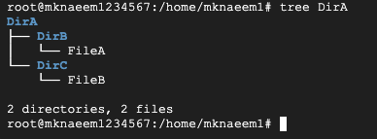
  2. Now capture your screen and paste it below:  
       
     **[paste your screenshot here]**
  3. Now, using the same commands that you have just learnt, create the following directory arrangements:  
       
     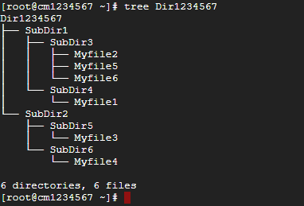  
       
     Make sure that you use your own Student ID for the first directory "Dir1234567".
  4. When successful, capture your screen and paste it below:  
       
     **[paste your screenshot here]**

**!!!Shutting Down Your Server/VM Instance!!!**

In order to close your virtual server, you must shutdown both the server (via the command line) and close the VM Instance

**WARNING: You must stop your instance from running otherwise it will stay on incurring charges!!!**

1. **Shutdown the Server:**

Shut down the Linux server, by typing in the following command

**shutdown -h now**

1. Stop the VM Instance

Return to **Google Cloud Platform** main screen

In the **VM Instances** section, click on the **STOP** button (below)

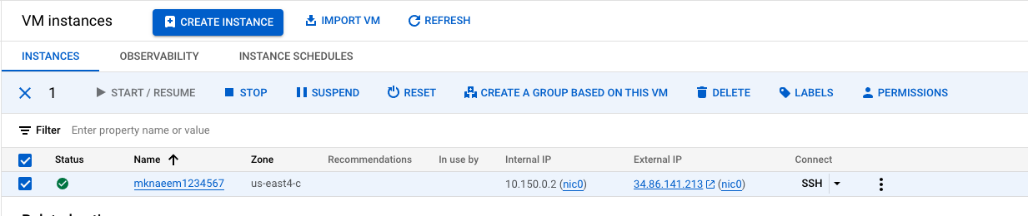

You should see a message similar to below,

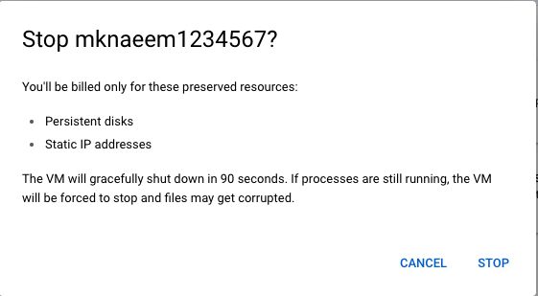

**Final Questions:**

1. Why do you think we are managing the Linux server in text mode rather than graphical mode? (Write what you think. **Do not ask the workshop tutors the question**.)  
     
   **(your answer here)**
2. What are the advantages of having your server on the cloud? What are the disadvantages?

**(your answer here)**

**This is the end of this workshop. If you have finished the workshop, please save you work.**